Q1. Types of Data Analytics
1- Descriptive: what happened? To know what is the problem from the historical data / the total sales is decreased
2- Diagnostic: why is this happened? Examines historical data to determine the root cause of the issue / sales dropped by 15% in a clothing branch last month
3- Predictive: what will happen? Use historical trends, and machine learning techniques to forecast future probabilities / An ecommerce company uses historical purchasing behavior to forecast demand for winter apparel.
4- Prescriptive: What should we do? Evaluates multiple scenarios and recommends the best action to optimize business outcomes / A logistics company uses optimization algorithms to automatically calculate and recommend the most efficient delivery routes for drivers in real time.
Q2. Data Types
1- Categorical Data
a- Nominal Data: Qualitative data grouped into mutually exclusive categories with no logical order or ranking / Payment method
b- Ordinal Data: Qualitative data with categories that follow a logical sequence or ranking / Customer satisfaction ratings
2- Numerical Data
a- Discrete Data: Quantitative data consisting of distinct, countable whole values that cannot be meaningfully divided into decimals / The total number of items purchased in a single shopping transaction
b- Continuous Data: Quantitative data measured on a continuous scale that can take any value within a given range, including fractions and decimals / The total price paid at checkout
Q3. Data Cleaning : is the process of detecting, correcting, or removing inaccurate, incomplete, duplicate, or improperly formatted records from a raw dataset
Important because uncleaned data leads to flawed insights, inaccurate statistical models, and bad business decision
a- Missing Values : Depending on the context and volume of missing data, an analyst can either impute the missing entries or drop rows with missing data
b- Duplicate Records: Identify primary keys or unique transaction IDs and apply deduplication functions to keep only a single unique instance
c- Inconsistent Data Entry: Standardize data values using string transformation functions
Q4. Business Understanding
Understanding the business problem before diving into data analysis is critical because it gives purpose and direction to the entire analytical process. Without a clear business context, an analyst risks solving the wrong problem, analyzing irrelevant variables, or drawing mathematically correct insights that have no practical business value
Suggested Business Problem: The business wants to understand customer purchasing behavior and identify which product categories generate the highest sales, so it can improve inventory planning and marketing strategies.
a- What is the average Purchase Amount and total revenue generated across different product categories
b- Is there a difference in average purchase amounts between discounted and non-discounted purchases?
c- What is the average purchase amount across different seasons?

1-COUNT 0f Purchase Amount (USD) : The COUNT function counts the cells that contain numeric values. In this dataset, it counts the purchase amounts in the Purchase Amount (USD) column. The result is 3,900, indicating that all 3,900 purchase amount cells contain numeric values.
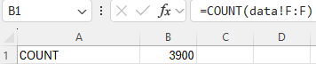

2- COUNTA of customer ID: The COUNTA function counts all non-empty cells, including cells containing text or numbers. In this dataset, it counts the non-empty Customer ID cells. The result is 3,900, meaning that all records contain a Customer ID.
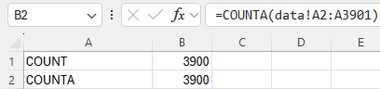

3- COUNTIF clothing: The COUNTIF function counts the cells that meet a specified condition. it counts the records where the Category is Clothing. The result shows that 1,737 records belong to the Clothing category.
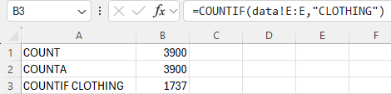

4- AVERGAE purchase amount: The AVERAGE function calculates the arithmetic mean of numeric values.. The average purchase amount is approximately $59.76.
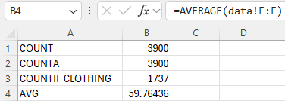

5- AVERAGEIF purchase amount for records in the Clothing category: The AVERAGEIF function calculates the average of values that meet a specified condition. The average purchase amount for Clothing is approximately $60.03.
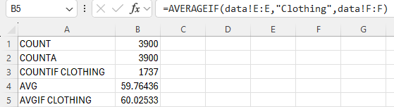

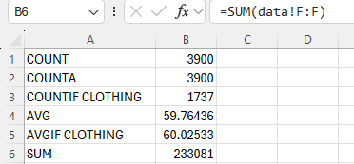
6- SUM purchase amount: The SUM function calculates the total of numeric values in a selected range. The total purchase amount is $233,081.

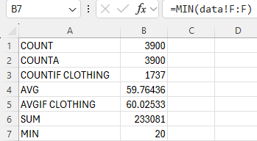
7- MIN purchase amount: The MIN function returns the smallest numeric value in a selected range. it identifies the minimum recorded purchase amount, which is $20.

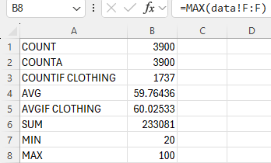
8- MAX purchase amount: The MAX function returns the largest numeric value in a selected range. it identifies the maximum recorded purchase amount, which is $100.

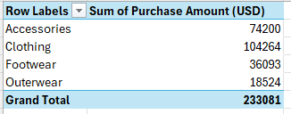
1-Business Question: Which product category has the highest total purchase amount? Clothing
ROWS: category values: purchase Amount aggregation: SUM

2-Business Question: How does the average purchase amount vary across product categories and seasons?
ROW :Season columns: category values: purchase Amount aggregation: AVG
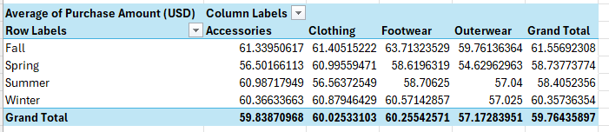
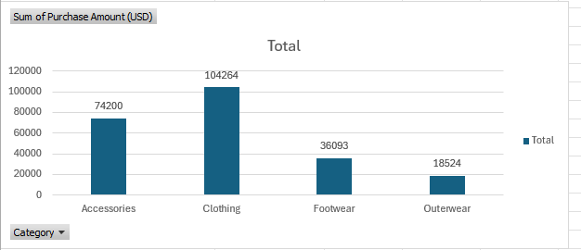
Business Question: Which product categories generate the highest total revenue for the business?

a- Clothing is the highest-performing category, generating a total revenue of $104,264 / Footwear ($36,093) and Outerwear ($18,524) contribute significantly lower total revenues
b- Accessories follows strongly in second place with $74,200 in total sales
Marketing budgets and inventory allocation should prioritize Clothing and Accessories to maximize ROI, while promotional bundles or discounts could be introduced to boost sales in the lagging Outerwear and Footwear segments
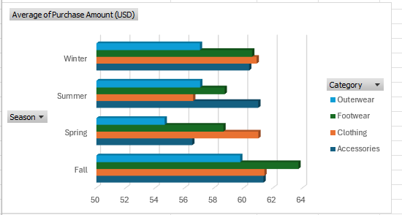
Business Question: How do average purchase amounts vary across different seasons and product categories?
a- Fall displays the highest spikes in average transaction value, notably for Footwear (reaching nearly $64) and clothing ($61)
b- Clothing and footwear maintain high average ticket sizes during Spring (both hovering around $59–$61)
c- In summer accessories leads the summer months with an average purchase amount exceeding $61
d- In winter clothing and Footwear maintain strong averages near ($61–$62) USD
Purchase averages vary by season rather than following a single static trend. Retail and pricing plans should target these seasonal spikes for specific categories, like marketing high-end footwear ahead of Fall and showcasing clothing lines before Spring.

*SQL:
1- Filtering and Sorting : This query retrieves employees from department 50 whose salary is between 3000 and 8000, and sorts the results by salary in descending
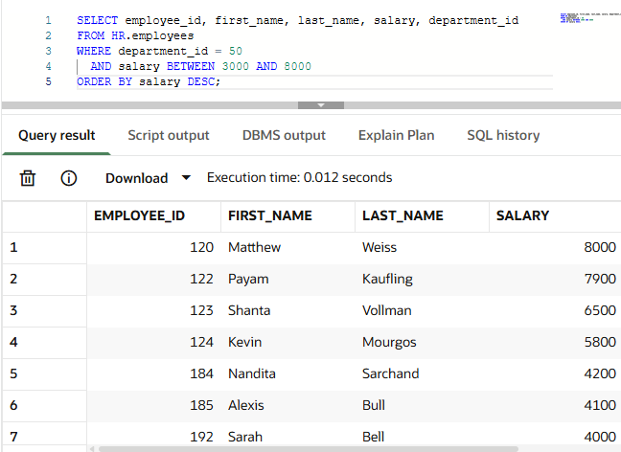

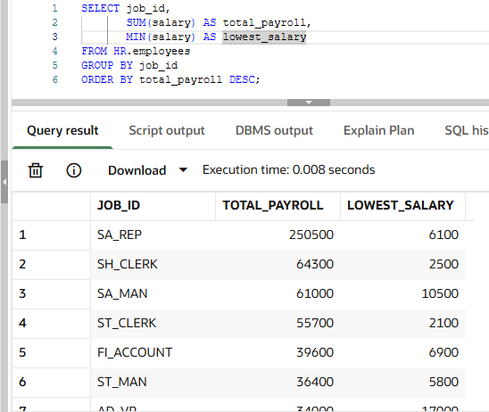
2-Aggregation and Grouping: This query groups employees by their job ID to calculate the total payroll expenses and the lowest salary for each role, ordered by the total payroll from highest to lowest.

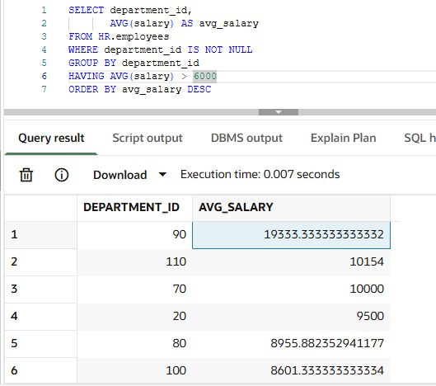

3-Filtering Groups: This query groups employees by department, calculates the average salary for each, and filters the results using HAVING to show only departments where the average salary is greater than 6000.

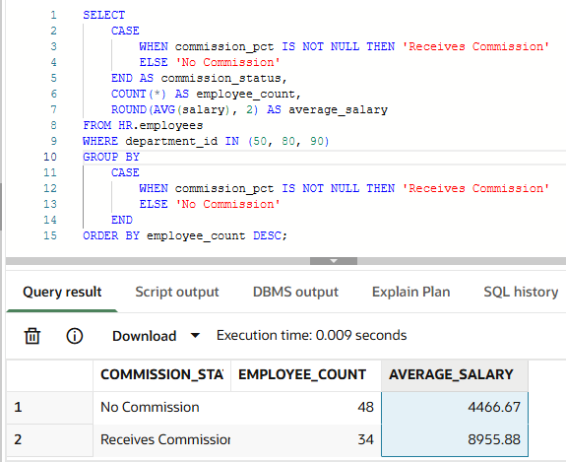
Your Business Question:
This query classifies employees in specific departments (50, 80, and 90) into two groups based on whether they receive a commission or not, then calculates the total employee count and average salary for each group

Python Findings

Insight 1 – Category Performance
Clothing recorded the highest total purchase amount at $104,264, representing approximately 44.7% of the dataset's total purchase amount. Footwear had a slightly higher average purchase amount of approximately $60.26. Management should consider both total amount and average amount when comparing product categories.

Insight 2 – Seasonal Differences
Fall recorded the highest average purchase amount at approximately $61.56, while Summer recorded the lowest at approximately $58.41. Management could investigate seasonal customer preferences, promotions, and product availability to better understand these differences.

Insight 3 – Discount Status
Records with a discount applied had an average purchase amount of approximately $59.28, compared with $60.13 for records without a discount. This difference is descriptive and does not prove that discounts reduce spending. Further analysis is needed before changing promotional policies.

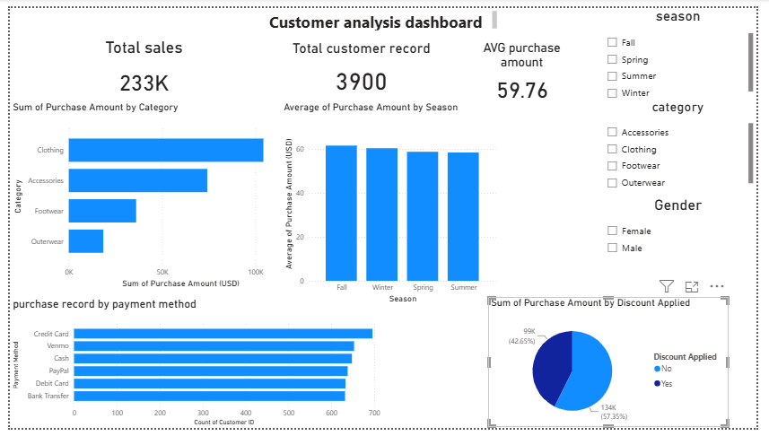
Key Business Insights
Insight 1 – Category Performance
Clothing recorded the highest total purchase amount at $104,264, representing approximately 44.7% of the total purchase amount of $233,081. This category also had the largest number of records.
Insight 2 – Seasonal Differences
Fall had the highest average purchase amount at approximately $61.56, while Summer had the lowest at approximately $58.41. The difference was about $3.15 per record.
Insight 3 – Payment Method Usage
Credit Card was the most frequently recorded payment method, with 696 records. Bank Transfer had 632 records. Management can investigate customer preferences across payment methods.

Recommendations for Management

Recommendation 1 – Product Category Planning
Review inventory availability and replenishment needs for Clothing, which recorded the highest total purchase amount. Consider product costs, profit margins, and stock levels before making inventory decisions.
Recommendation 2 – Seasonal Promotion Testing
Test a targeted promotional campaign during Summer and compare its results with a comparable group that does not receive the promotion. Measure purchase amounts and profit margins before deciding whether to expand the campaign.

